Assignment: UX extension

Analysing three apps for the UX design patterns they all include. The apps are Youtube, google docs and Notion. The patterns identified and discussed are the Navigation bar, and search filter are identified for all three apps, another UX pattern identified is a home link which is seen only in two of the apps such as Youtube and goggles docs however not is a notion. This is because the purpose of Notion is for the user to create pages so there is no distinct home page. Therefore, the third UX pattern identified in Notion was settings.

Application analysis

### Youtube

| **Pros** | **Cons** |
| --- | --- |
| * Youtube functionality, and the UI look presentable and neat as all needed features are there and viable. * UI matches the computer version similar to how google docs have done it. Therefore, users who are already accustomed to the computer UI can use it more easily. | * It is evident that this application is for watching videos. Not really editing account details or history. Such as the user won't be able to delete history in mass only select a video at a time to delete. * History only contains watch history so not comment history. |

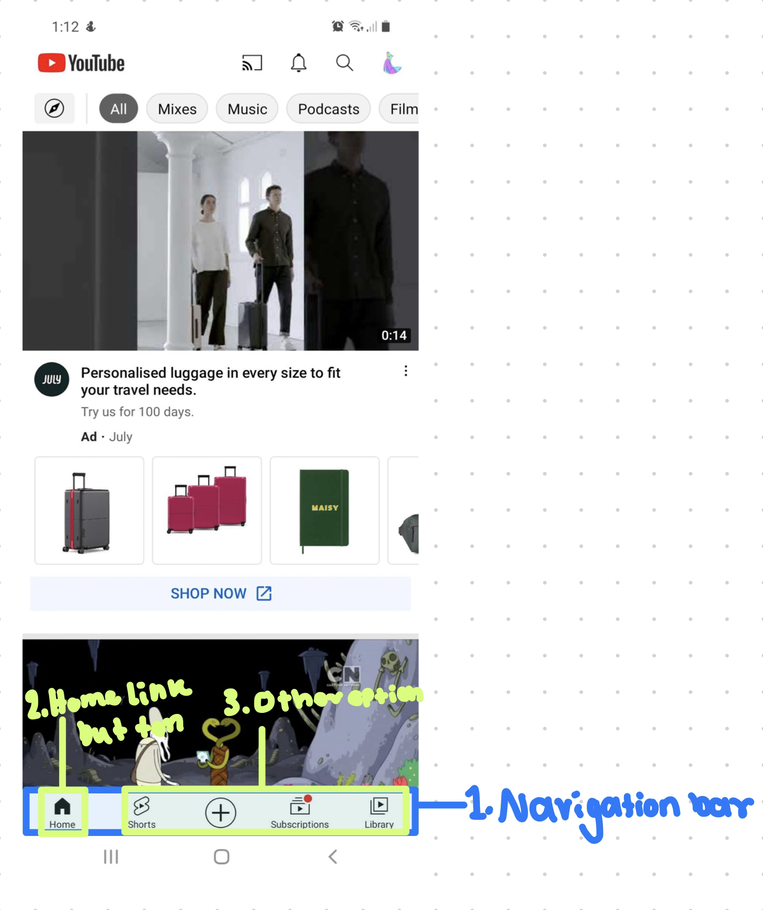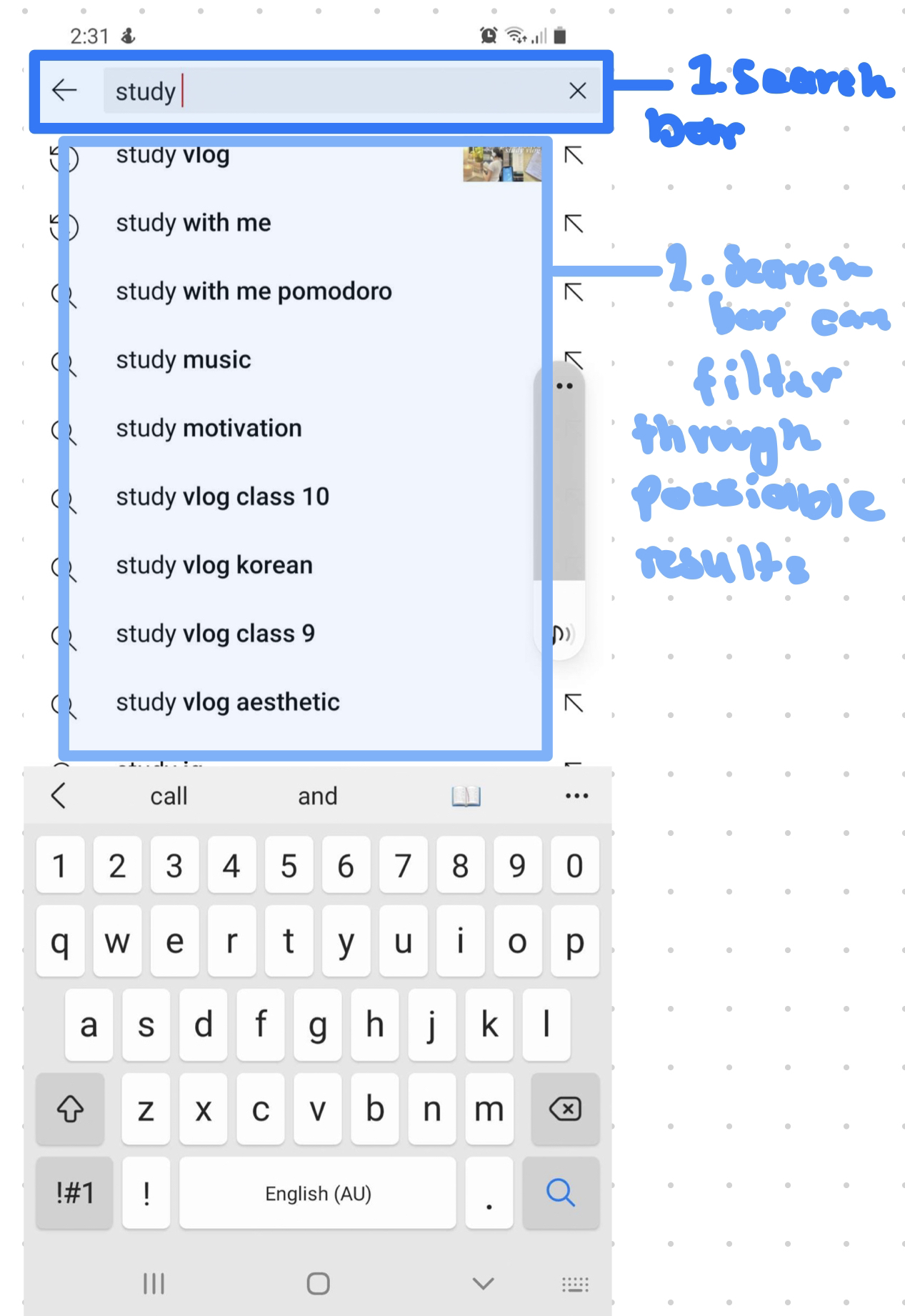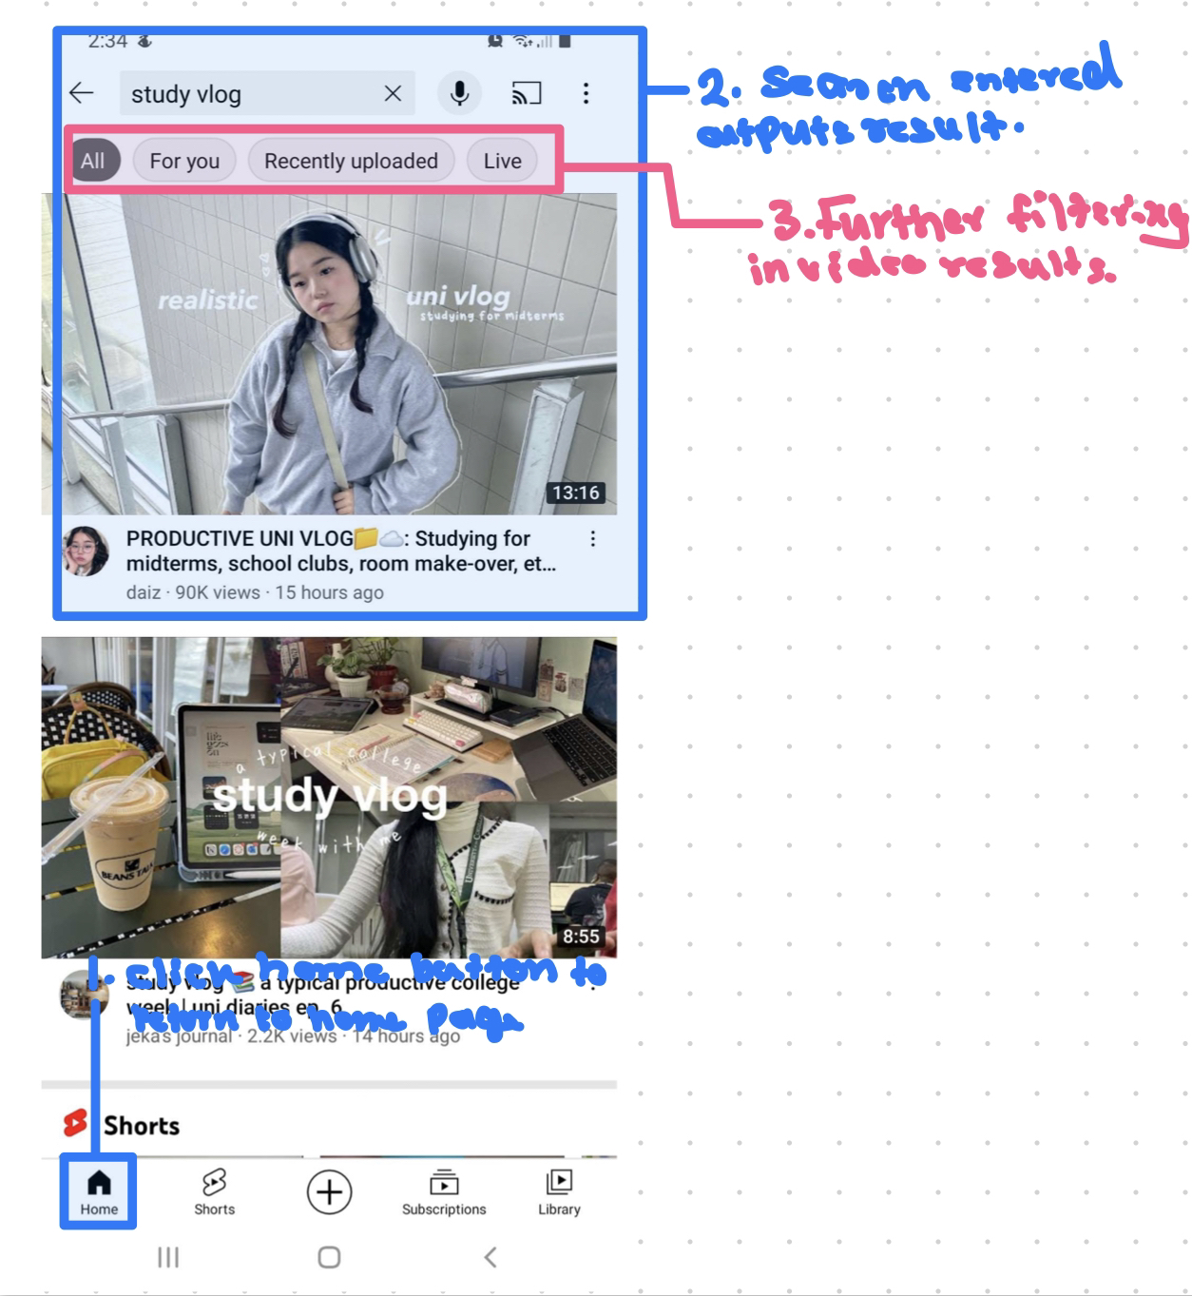

**Navigation bar**

In the youtube application, there is an example of a navigation bar that is placed at the bottom of the screen. It is labelled *1.Navigation* bar, is in the image. It is evident that this is an example of a navigation bar as this that the navigation bar uses 2 - 9 sections of information that navigate to other pages and the information is also labelled in short names. The entire navigation bar itself is wide as the screen. The pages it navigates to also are the more important and are the highest available sections to the application. Moreover, the navigation is simple and general regarding what selection options there are and these selection options also expand and have further options as well. Therefore, for these reasons adhere to the UX pattern of the navigation bar.

**Search Filters**

Another, UX pattern that youtube demonstrates is the search filter. This is depicted to use the search bar to search a certain name of a video or the creator of the video itself, furthermore, the search bar itself filters what the user has typed to similar results to what string the user is typing. Also, there is another type of filter that appears when you are on any page. Where users can select specific categories to add to their search results. Henceforth, it can be demonstrated that the search filter in the youtube application is an example of a UX search filter pattern. As the filtering either in the search results when the user types in the search bar can decrease the possible results as the user types more of a cohesive string into the search bar. In addition to this users can select a category in which the specific videos in that category will be filtered and appear, as well as decrease the number of videos appearing to users, from a large amount to a small amount.

**Home Link**

Another UX design pattern that appears in the youtube application is the home link which appears in the navigation bar. This home button link appears on every page due to it being attached to the navigation bar, and this adheres to the UX pattern design principles as the home button enables the user away to escape to the home page. If they entered the app using a youtube video link and want to exit that video and go back to the home page. Therefore adhering to the UX pattern design principle.

### Google docs

| **Pros** | **Cons** |
| --- | --- |
| Functions and features clearly depicted to the user.  * Symbols representing functions and features are easily interpreted. * All possible tabs are easily understandable and match the computer version of the app, hence an individual who uses google drive will be able to easily use this. | The search filter enables users to narrow down the search however there are only two categories comparatively the computer version of google drive there are multiple. |

### 

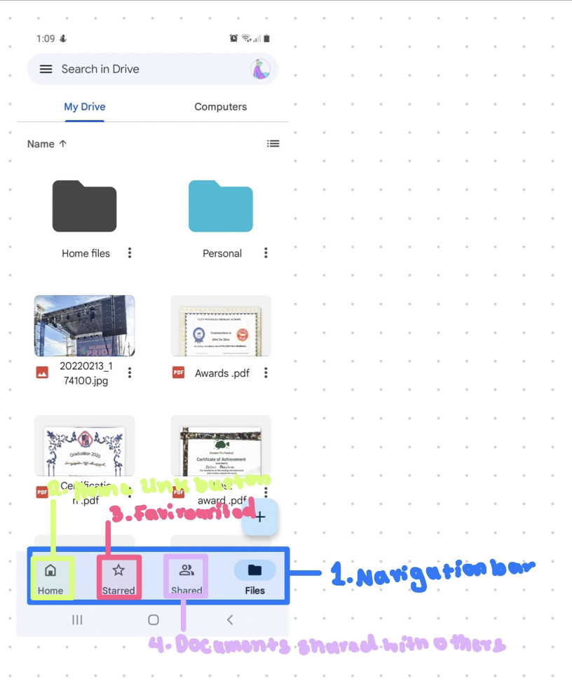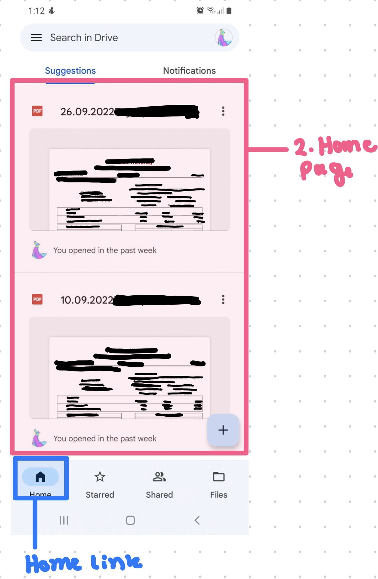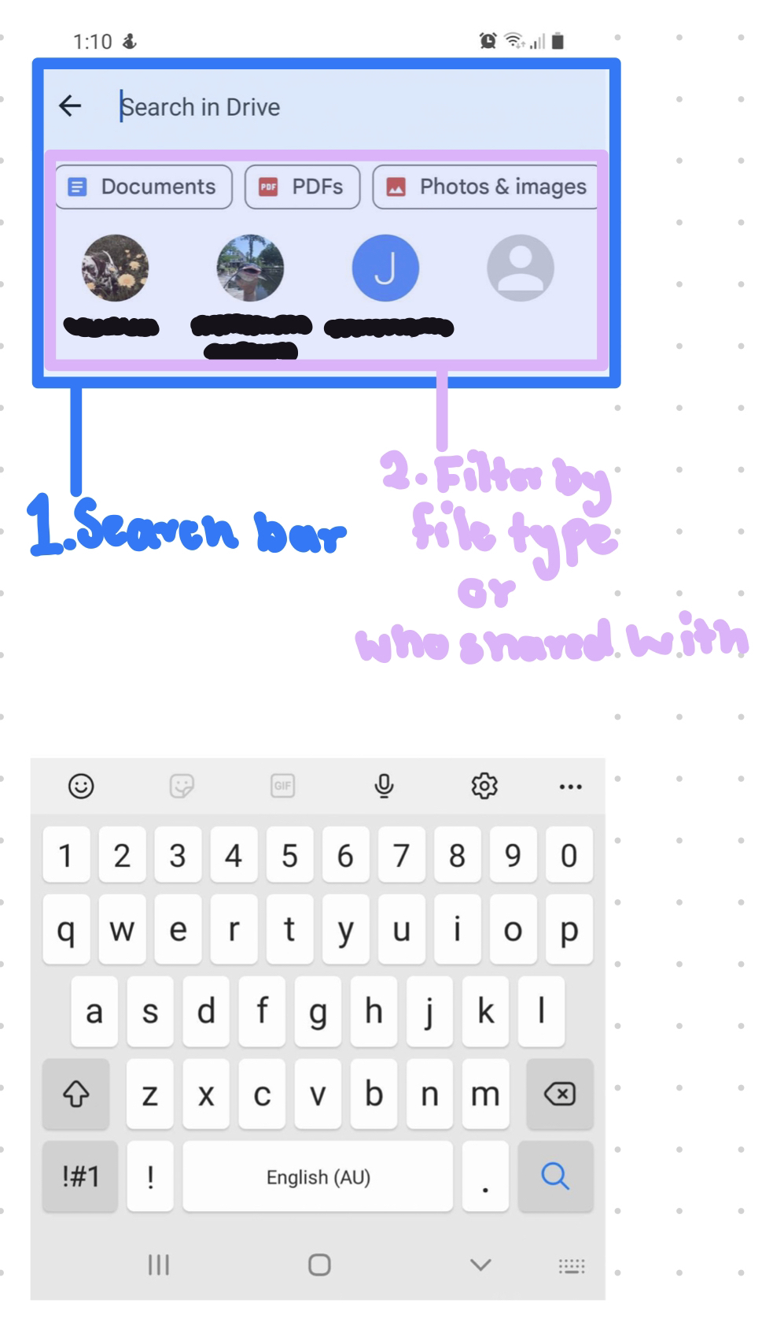

**Navigation bar**

Google doc app has navigation that appears at the bottom of the screen and gives many options to popular pages which the user would more likely be using. The navigation bar is an example of the UX pattern as it has 2- 9 selection options, and the names of those selection options are relatively short. The navigation bar even though at the bottom of the page, takes up the entire width of the page the user is viewing. It is noted that this is similar to how youtube has placed its navigation bar. The pages the navigation bar has are pages that are in the main pages of the application which open up to other pages hence the highest hierarchy of pages or the ones included in the navigation bar.

**Search filter**

The search filter is present in the google docs application located when users search their drives. Users can filter by file types, such as document, PDF and photo & images. In addition below in the filter fragment, their users can filter their search by who a file was shared with. Seen in the image above highlighted. In addition to this, the search result entered in the search bar automatically filters results depending on what the user is typing. This is if the user hasn't selected document types. Furthermore, these filters adhere to the UX design patterns as they firstly reduce the number of possible results, thus reducing the time users have to look for the result they want. As well there are categories the user can filter through such as file type of shared users. Therefore, adhering to the requirements of the UX pattern search filter.

**Home Link**

Home link UX design pattern in google docs is located in the navigation bar. Therefore, appearing on any page. The home link button fulfils the requirements for the UX pattern, as it returns the user to the home page from any other page they may have opened the app as demonstrated in the image above.

### Notion's

| **Pros** | **Cons** |
| --- | --- |
| * Functionally all the widgets translate well and are functional. * All important features are clearly placed in the navigation bar where users will see them clearly. | * The UI seems to almost be taking the UI of the computer version of Notion and squishing it into the phone screen. Where you can see that for example the To-do list page appears squished and not fully appearing on your mobile. |

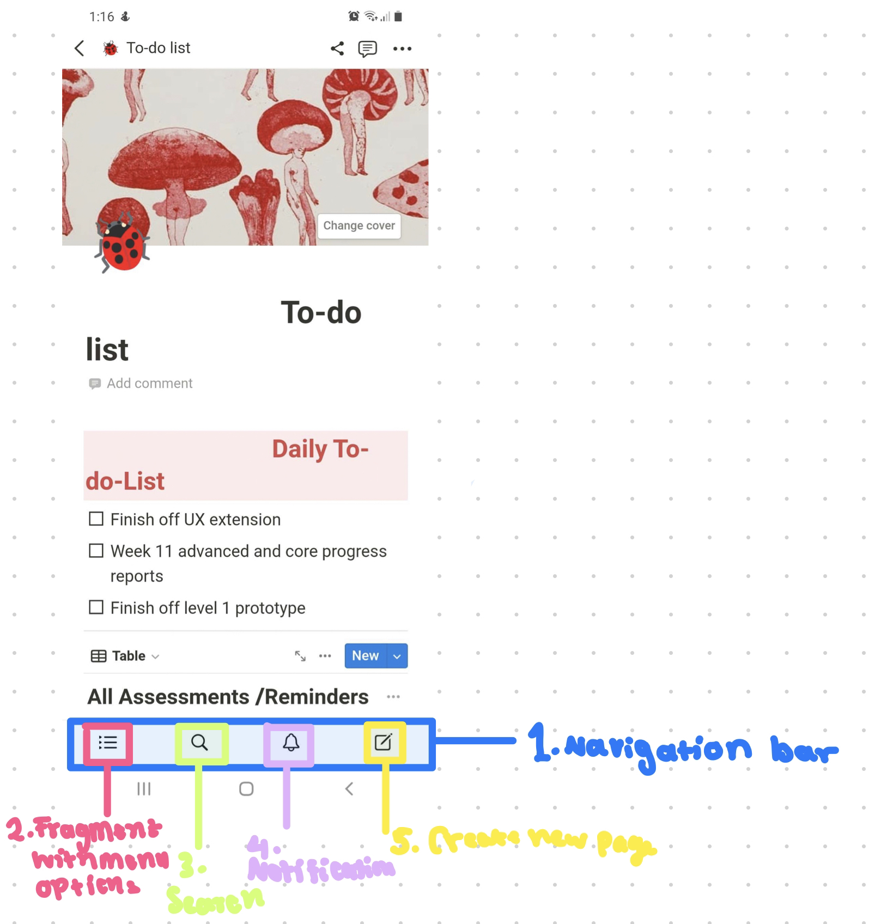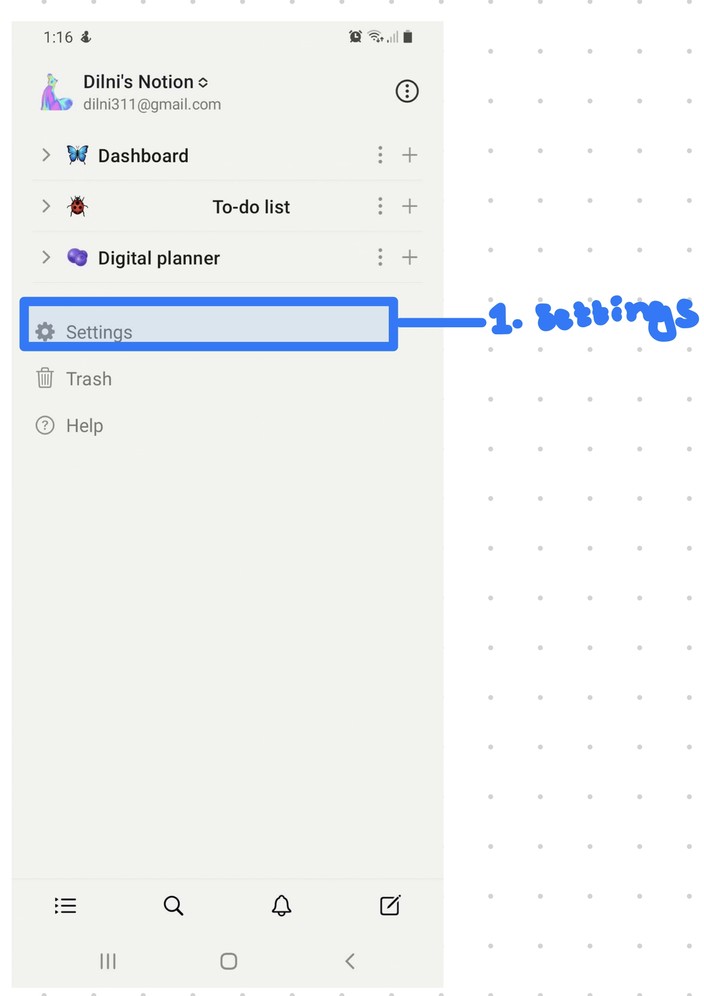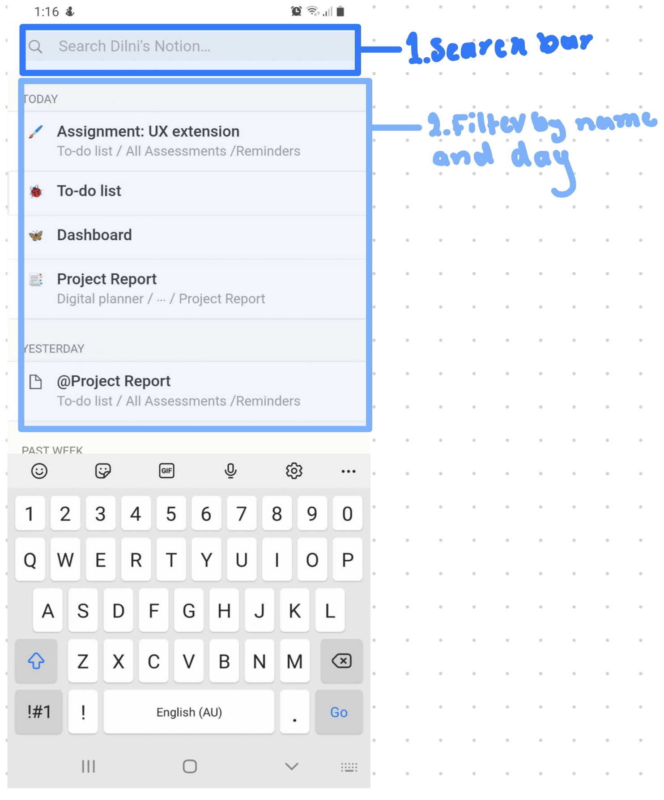

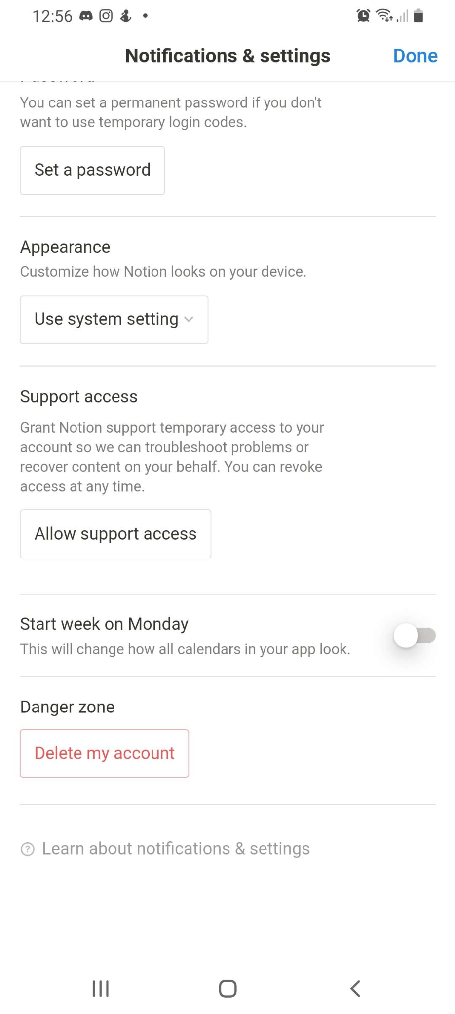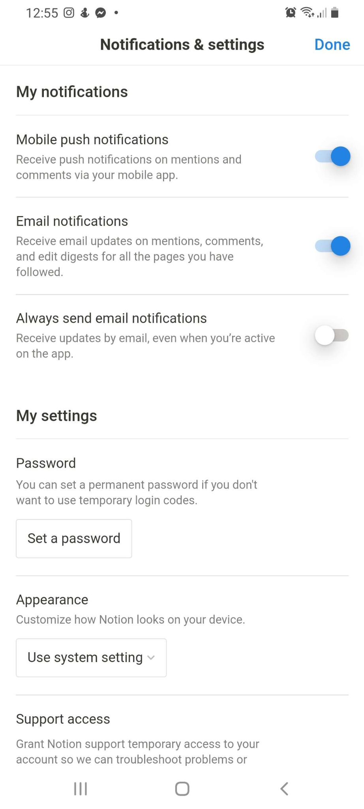

**Navigation bar**

The navigation bar in Notion again similar to the navigation bar in both youtube and google drive has 2 - 9 selection options as well the names are relativity short, and the bar itself is wide as the screen. Thus adhering to a UX design pattern.

**Search filter**

Search filters in notion are identified to be two versions. Either when the user opens the search page from the navigation bar displaying the search bar. Then also showing recently opened pages. These pages as seen in the image are organised by day such as today, yesterday and upcoming. Therefore categorising search results as have been previously entered and organised by date, is done automatically when the user opens the search page to what the user has last opened. Therefore, adhering to UX design patterns of categorising filters. In addition, the search bar also has an automatic filtering system to match user-entered strings. Ultimately, decreasing the search results the user can type as the search result they want can be auto-entered.

**Settings**

The settings menu design confirms that the settings in Notion adhere to the UX design patterns. As both essential and not as essential user options are used by the majority of users are using. This is evident in the first setting title My notification. These settings options generally are the majority of the time what the user will be needing, as well as an essential option as there are features in the app where notifications are needed such as calendar date. In addition, certain options are put at the bottom of the menu such as support access and delete account. These options can both be interpreted either as options that are not as used by the user or users or can be enterprised as dark UI that the company does not want to the user for example have users delete their account. Therefore, adhering to the UX design patterns.

## Referencing:

1. UI patterns, 2007-2022, *Navigation Tabs,* UI patterns, <https://ui-patterns.com/patterns/NavigationTabs>
2. UI patterns, 2007-2022, *Search Filters*, UI patterns,<https://ui-patterns.com/patterns/LiveFilter>
3. UI patterns, 2007-2022, *Home Link*, UI patterns,<https://ui-patterns.com/patterns/HomeLink>
4. UI patterns, 2007-2022, *Settings*, UI patterns,<https://ui-patterns.com/patterns/settings>

Assignment: UX extension (add-on) on Sketches and Patterns - Report Submission

Assignment: Extension (add-on) on Performance - Report Submission